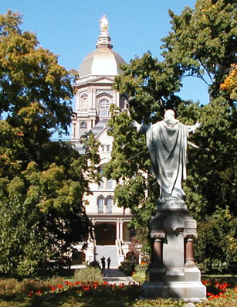
You and your family are
cordially invited to

A Reception Honoring the 2019 Graduates
Department of American Studies
And
John W. Gallivan Program in Journalism, Ethics & Democracy

Friday, May 17th – 1:30 pm
Seven on 9 Corbett Hall
(Enclosed)
University of Notre Dame

Please join us to celebrate the many accomplishments of the Class of 2019.
Please RSVP to Katie Schlotfeldt at kschlotf@nd.edu or by phone at (574) 631 – 4260 with the total number of your party that will be in attendance.

You and your family are
cordially invited to

A Reception Honoring the 2019 Graduates
Department of American Studies
And
John W. Gallivan Program in Journalism, Ethics & Democracy

Friday, May 17th – 1:30 pm
Seven on 9 Corbett Hall
(Enclosed)
University of Notre Dame

Please join us to celebrate the many accomplishments of the Class of 2019.
Please RSVP to Katie Schlotfeldt at kschlotf@nd.edu or by phone at (574) 631 – 4260 with the total number of your party that will be in attendance.

